**Git Commands**

1. **git --version** : Describes the version of git installed in machine

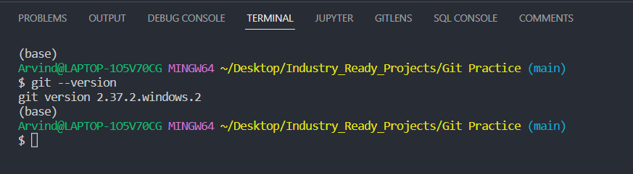

1. **git config** : It is used for configuration of git in system

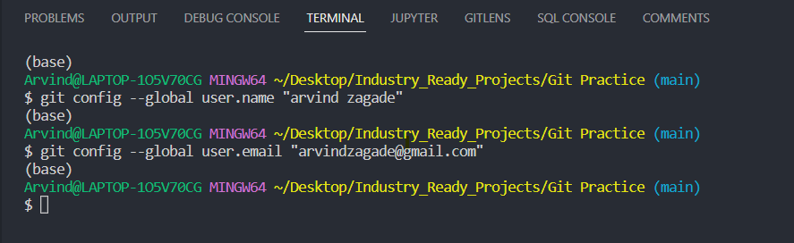

1. **git init** : initialize the git in system

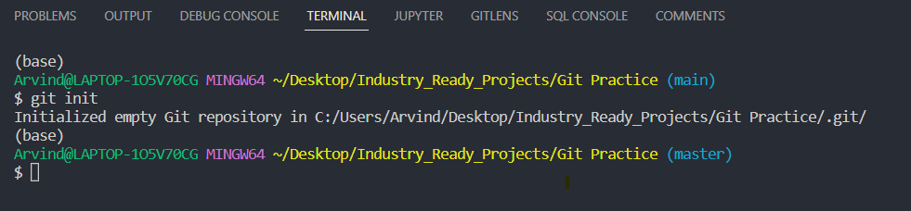

1. **git status:** used to display the status of git (files)

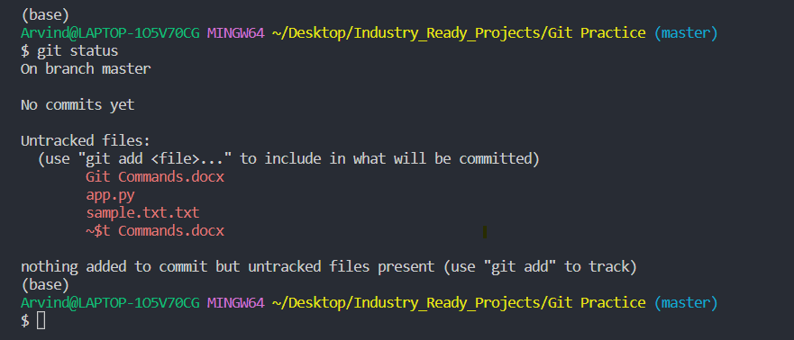

1. **git add .** :- This is used to staged the untracked files

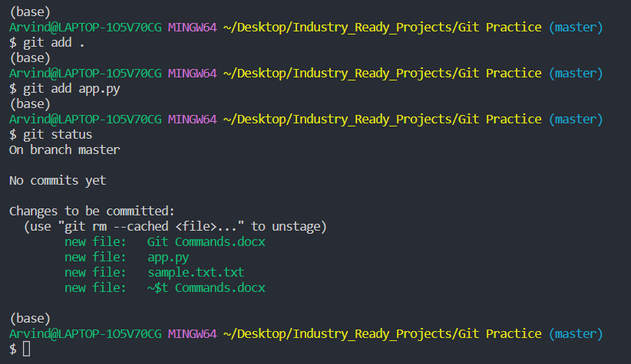

1. **git commit** :- Used to commit any added files in the repository with git add and also commits any files you have changed after that.

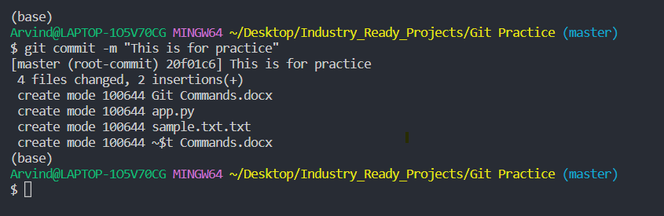

1. **git checkout** :- used to undo changes in the file

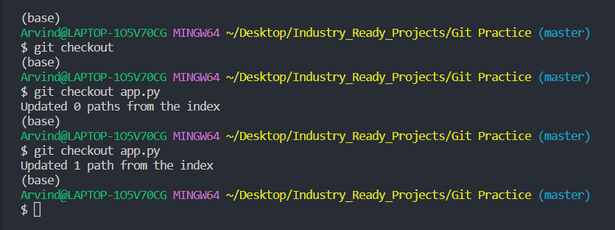

1. **git diff** :- Used to check the changes in the files

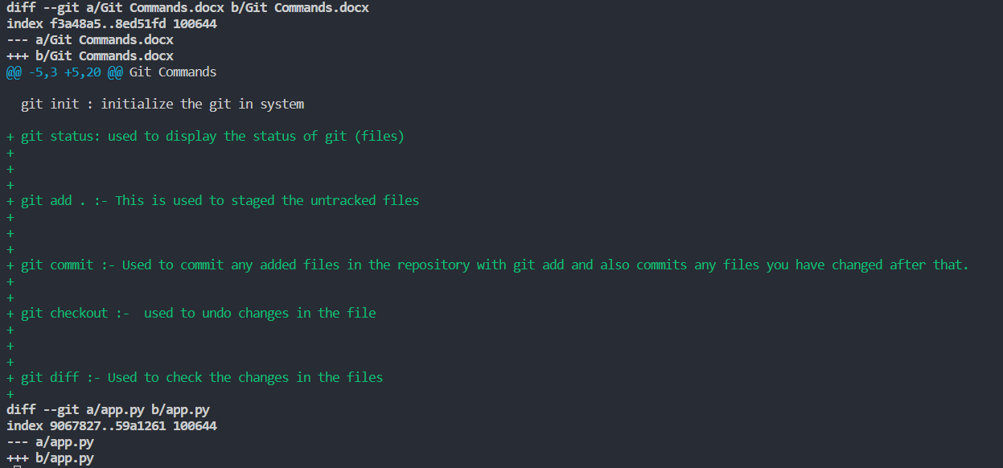

1. **git branch**: - Shows the current git branch

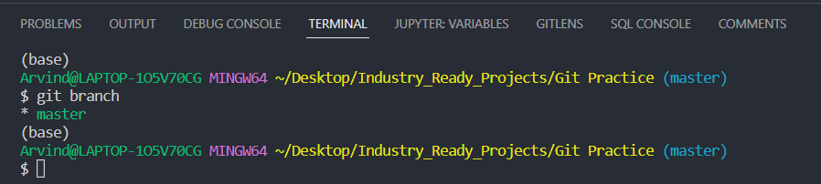

1. **git push origin main**: To push the changes (files) in the branch to github repo.

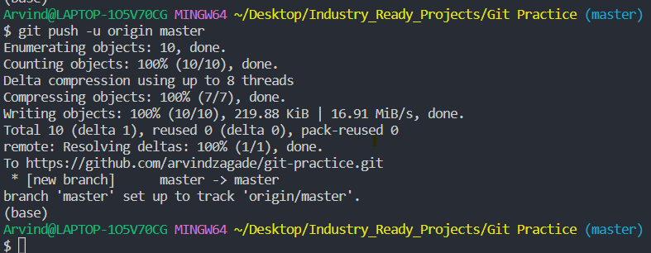

1. **git branch new_branch<branch name>** :- This is used to create a new branch.

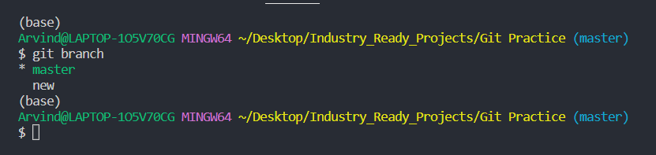

1. **git show**:- Used to view expanded details on git objects

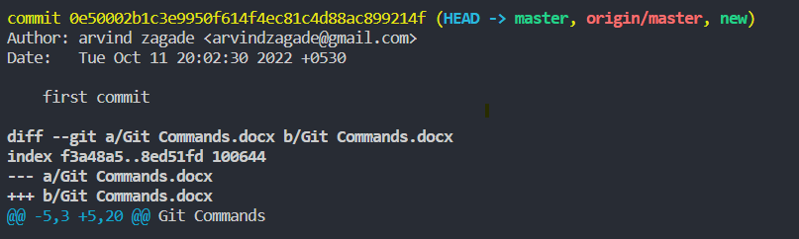

1. **git log** :- used to display the git logs.

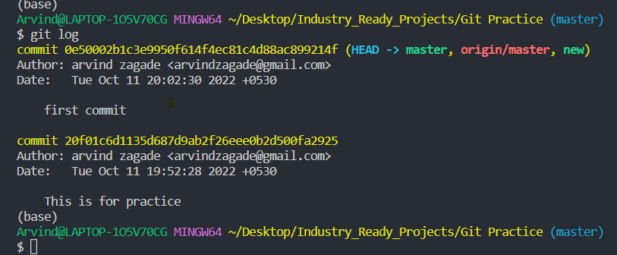

1. **git merge**:- Git merge will combine multiple sequences of commits into one unified history.

In most frequent cases, git merge is used to combine two branches.

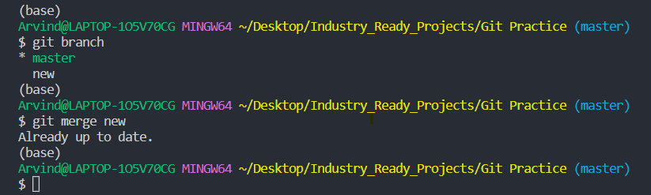

1. **git branch -d new_brach <branch name>:**

This command deletes the newly created git branch from GitHub repo

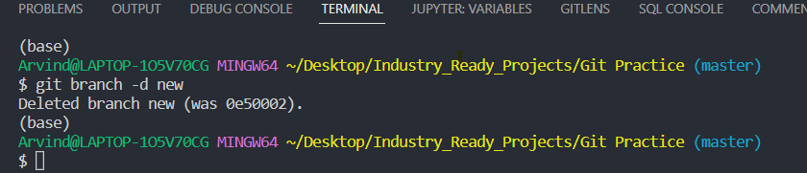

1. **git reflog**:

Git keeps track of updates to the tip of the branches using mechanism called reference logs, or “reflogs.”

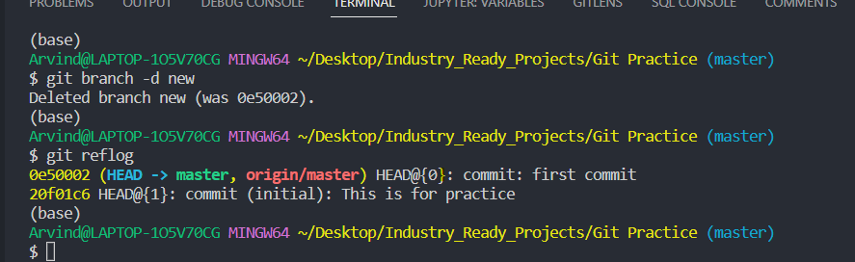

1. **git show :**

git show is a command line utility that is used to view expanded details on git objects such as blobs, trees, tags and commits.

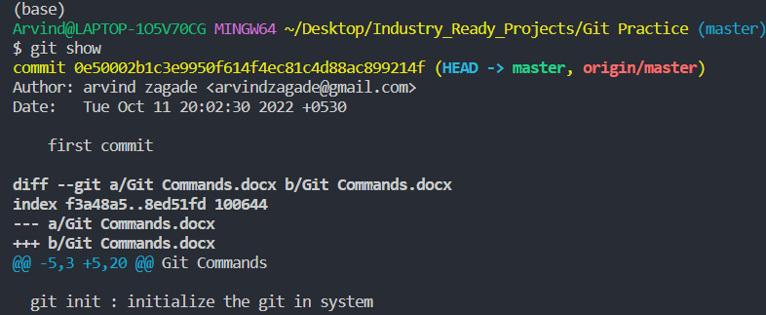

1. **git clone :**

This is used to clone the others git repository

